29 Jan 20, Goss

Need to create new data tables for the website based on my localdb tables.  Screen shots follow.

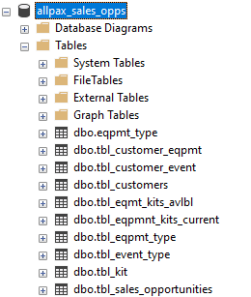

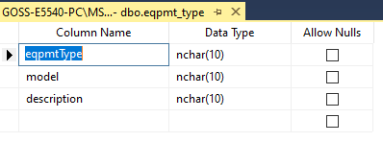

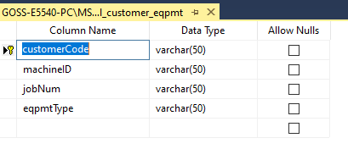

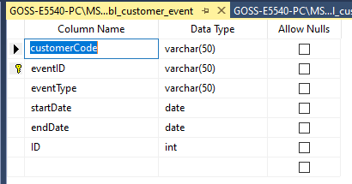

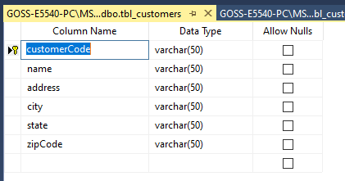

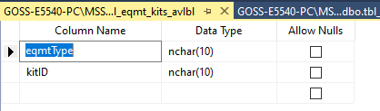

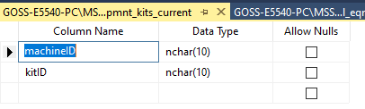

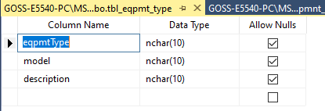

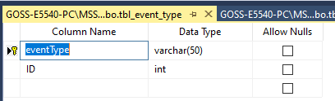

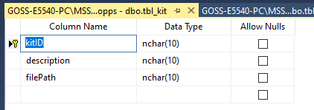

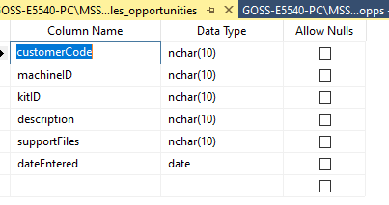

Notes:

1. De-select allow nulls.
2. Do not use nchar.  Use varchar.
3. Key will not be as shown in these screen shots.  Will be an auto increment number instead.
4. After a table is created, create an auto increment column. <https://stackoverflow.com/questions/3698793/how-to-add-a-new-identity-column-to-a-table-in-sql-server/3698824>



Result:

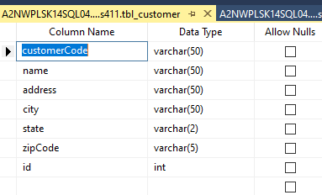

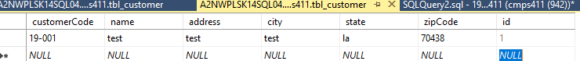

1. Set this auto increment column to be the key.